OBJECTIVE QUESTIONS

Question 1: What is the total no. of attributes present in the data?

Solution:

Final Answer (if any):
Total no of attributes is 16.

Approach (if any):
Count the columns in “Tickets” and “IT Agents” sheet.

Charts & Tables (if any):

Tickets:

IT Agents:
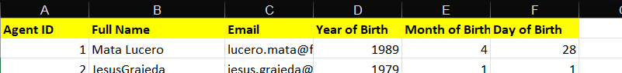

- Description:
The tables represent the columns which are counted to find out total no of attributes in whole data consisting of “Tickets” and “IT Agents” sheet.

Question 2: Which columns have inconsistent or missing values, and what is the count of such values?

Solution:

Final Answer (if any):
No columns have missing values. Only formatting and transformation are required during cleaning for Severity and Priority.
Approach (if any):
Check Duplicates,Count of each column for null/missing values and transforming severity and priority column to remove numbers and spelling corrections.
Charts & Tables (if any):
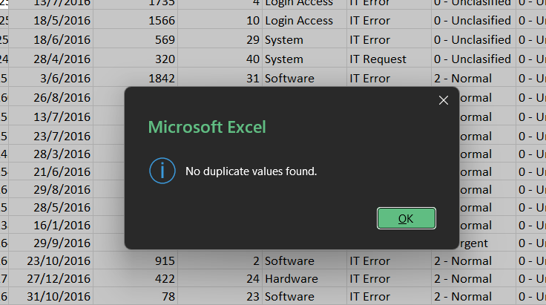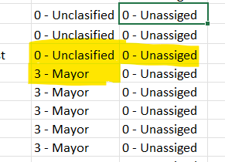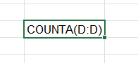
- Description:
Displays the count of missing values, duplicates check and identifies data consistency issues across all dataset columns.

Question 3: What is the average daily ticket volume over time?

Solution:

Final Answer (if any):
Average daily ticket volume over time is 53.37

Approach (if any):
Here, Average is calculated by total ticket/ total time where in total time considered each date in the calculation earlier resulting in an wrong result since same date occur multiple times and that is what we need to find i.e. for each date, hence using unique date will give distinct dates helping in calculation of average daily ticket volume over time.
Charts & Tables (if any): Q-3 I Objective

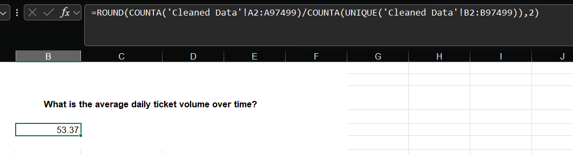
- Description:
Image shows the formula and the output which is round up to 2 decimal places using ROUND().

Question 4: What is the distribution of ticket categories (e.g., Login Access, System, Software)?

Solution:

Final Answer (if any):

The System category has the highest number of tickets while Hardware has the lowest ticket volume.

Approach (if any):
Created a pivot table with Request Category in rows and Ticket ID in values which gave count of tickets in each category.

Charts & Tables (if any):
- Table / Chart Name: Q-4 I Objective

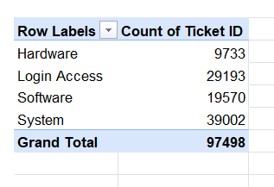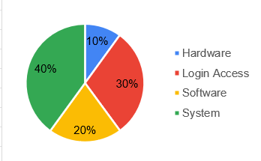

- Description:
Distribution of a category is best described by pie chart making it easy to identify category having highest or lowest tickets.

Question 5: How many tickets has each agent handled?

Solution:

Final Answer (if any):
Aurelio Tanori, Jesus Contreras and Elena Velez are among the agents who handled max tickets while Griselda Galindo handled least.
Row Labels | Count of Ticket ID
A. Trejo | 1949
Alberto Casillas | 1974
Alberto Gastelum | 1889
Aldo Carrillo | 1966
Alfonso Barraza | 1984
Alfredo Barreras | 1920
Armando Sierra | 1890
Aurelio Tanori | 2027
Barbara Grijalva | 2003
Barraza Alberto | 1988
Darwin E. | 1945
Diana Rojo | 1927
Eduardo Luna | 1920
Elena Velez | 2021
Enrique Montiel | 1938
Estuardo Ocano | 1935
EstuardoTorres | 1342
Eva Cardenas | 1345
Flores Sierra | 1963
Galindo Guadalupe | 1991
Griselda Galindo | 1856
Guadalupe Hernandez  Guadalupe Torrico | 1915  1987
Guadalupe Villanuevs  Isela Leyva | 1958  1968
Javier D. | 1897
Jesus Contreras | 2026
Jesus Pacheco | 1931
JesusGrajeda  Leon Lourdes | 1968  1961
Lopez Moran. | 1956
Lorena | 1966
Luis Arguello | 1929
Luis Torres | 1913
Marisol Piedrahita | 1360
Mata Lucero | 1969
Melinda | 2007
Miller Gaviris | 1892
Nurio Zepeda | 1946
Orci Carlos | 1326
Parra Luna | 1963
Ramon Macias | 1949
Reyna Santacruz | 1897
Ross Olguin | 1950
Sandra Lujan | 1906
Segura Garcia | 1931
Silvia Morales | 1974
Velasquez Jose | 1949
Willyberto Gonzales | 2000
Yomaira Aqudelo | 1933
Grand Total | 97498

Approach (if any):
Created a pivot table with Agent Name in rows and Ticket ID in values which gave count of tickets by each agent.

Charts & Tables (if any):
- Table / Chart Name: Q-5 I Objective
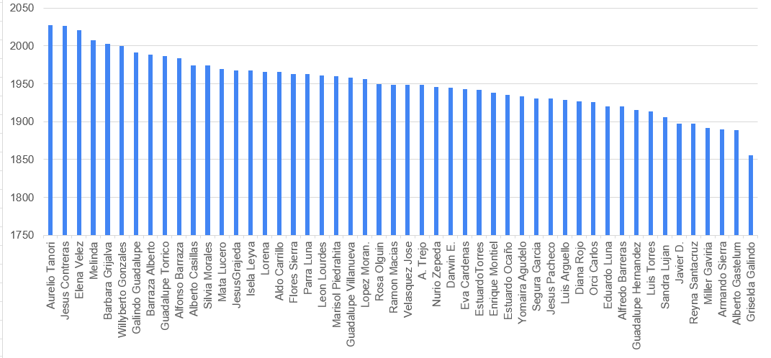

- Description:
Used clustered column chart and sorted it from high to low to find the agent with max and min tickets as there’s very less variation.

Question 6: How can you extract the domain from the email addresses in the IT Agents sheet?

Solution:

Final Answer (if any):
To find the domain name from the email i used,
=TEXTBEFORE(TEXTAFTER(C5,"@"),".") which gave me “fp20analytics” as a domain for all.
Approach (if any):
First, I started with TEXTAFTER to get text after “@” and got “fp20analytics.com”, then I enclosed the whole formula in TEXTBEFORE function to get text before “.” which gave the remaining part of the string which is domain name.

Charts & Tables (if any):

Question 7: How can you find the full name of an agent given their Agent ID?

Solution:

Final Answer (if any):
I used XLOOKUP to find the full name of the agent

Approach (if any):
I checked for a relation between two tables based on Agent ID and using that I used XLOOKUP to fetch agent full name for respective IDs.

Charts & Tables (if any):
- Table / Chart Name: Q-7 I Objective
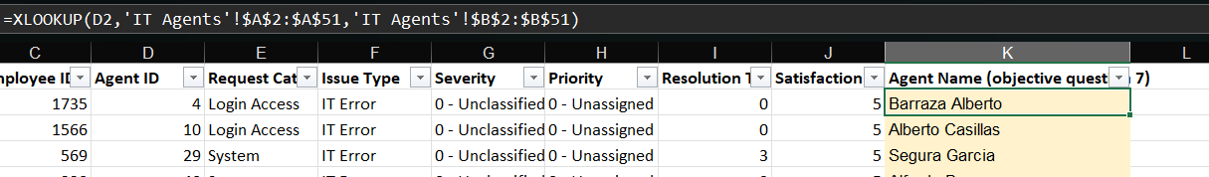- Description:
The image shows the formula used to look for agent full name and the resulted column.

Question 8: What is the count of each issue type (e.g., IT Error, IT Request)?

Solution:

Final Answer (if any):
The count of each issue type was calculated using the ticket count in pivot table. It shows the number of tickets raised under IT Error and IT Request.
Approach (if any):
Created a pivot table with Issue Type in rows and Ticket ID in values which gave count of tickets for each issue.

Charts & Tables (if any):
- Table / Chart Name: Q-8 I Objective
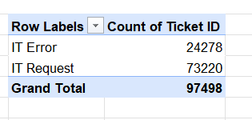

- Description:
The pivot table shows the count of tickets for each issue type and helps identify which issue occur more frequently which is IT Request here.

Question 9: What is the average resolution time for tickets?

Solution:

Final Answer (if any):
The average resolution time for tickets is 4.55 days calculated by finding the mean or average of the Resolution Time (Days) column.
Approach (if any):
I used the AVERAGE for Resolution Time (Days) column and round up to 2 decimal places to find the average resolution time for tickets.

Charts & Tables (if any):
- Table / Chart Name:
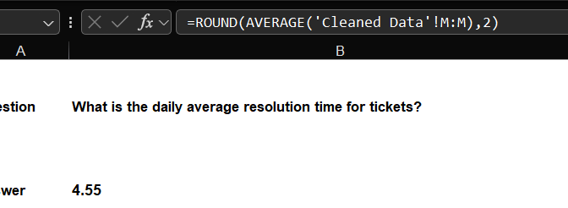- Description:
The image shows the formula used to look for average resolution time and the result.

Question 10: How has the volume of tickets changed over time?

Solution:

Final Answer (if any):
Ticket volume shows a continuous increase over time. The highest year-over-year increase was in 2020 of 35.36% and the lowest was in 2019 of 13.38%.
Approach (if any):
Created a Pivot Table with Date in rows and Ticket ID in values. Calculated yearly change and percentage in the pivot table but it was represented in the chart so calculated them separately in the sheet besides the pivot table to analyse the ticket volume in different years which clearly shows volume of tickets least in 2019 and most in 2020. The chart clearly shows the dip around 2019 and high volume of tickets around 2020.

Charts & Tables (if any):
- Table / Chart Name: Q-10 I Objective
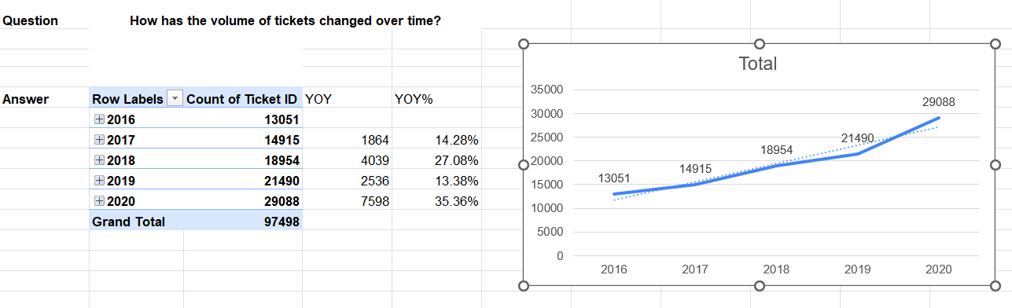
- Description:
The image shows pivot table, chart and calculations for yoy and yoy% representing changes in ticket volume over time.

Question 11: What is the average age of the IT agents?

Solution:

Final Answer (if any):
The average age of an IT agent is 41 years calculated by finding the mean or average of the Age column.

Approach (if any):
I used the AVERAGE for Age column and round up to 0 decimal places to find the average age of an IT agent.

Charts & Tables (if any):
- Table / Chart Name:
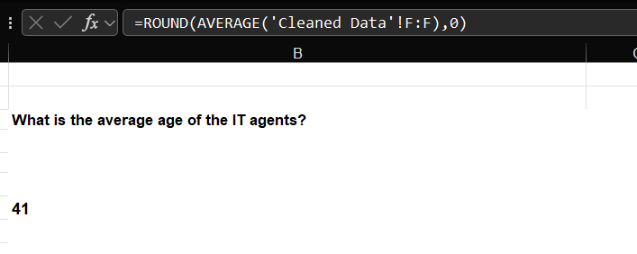- Description:
The image shows the formula used to look for average age and the result.

Question 12: Is there a correlation between the severity of issues and the resolution time?

Solution:

Final Answer (if any):
No, since correlation is −0.041 which is very close to 0, indicating almost no meaningful correlation between severity and resolution time. Urgent tickets resolve the fastest which is actually good.

Approach (if any):
Calculated corr value first by converting severity levels into numeric values then created a Pivot Table using the Severity in rows and Resolution Time (Days) in values with aggregation set to Average. Compared average resolution times across severity level to analyse the relationship between issue severity and resolution time.

Charts & Tables (if any):
- Table / Chart Name: Q-12 I Objective

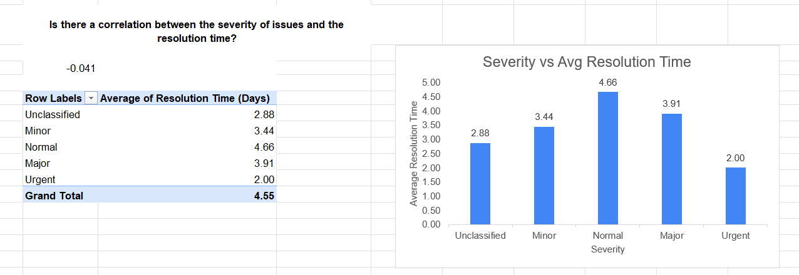
- Description:
The pivot table, chart and correl() is shown and supports the correlation analysis for severity and ticket resolution.

Question 13: How many categorical columns are there in the data? [Search about categorical and continuous data, and try to answer this question]

Solution:

Final Answer (if any):
The total number of categorical columns in Cleaned Data sheet is 7.
Approach (if any):
Categorical data columns:
- Agent Name
- Request Category
- Issue Type
- Severity
- Priority
- Quarter
- Month

Continuous data columns:
- Age
- Severity Level
- Priority Level
- Resolution Time (Days)
- Satisfaction Rate

Identifiers column:
- Ticket ID
- Agent ID

Date columns:
- Date
- Year

Charts & Tables (if any):

SUBJECTIVE QUESTIONS

Question 1: If there is an investment, should it be used to hire more IT agents, improve training programs, or upgrade ticket management software?

Analysis: Perform a cost-benefit analysis using ticket resolution and satisfaction metrics.

Solution:

Approach:
I will approach this question one by one starting with if hiring more IT agents would be a beneficial move by checking workload of IT agents which I checked by count of tickets/ count of agents (calculated separately) and added avg resolution time and satisfaction rate for more insights.
Next, if improving training programs would be beneficial is checked by calculating the agent’s ability to resolve unclassified and unassigned tickets for which I created two pivot tables grouped them by classified-unclassified,assigned-unassigned respectively and calculated count of ticket with resolution time and satisfaction rate.
Now, if upgrade in software is required can be see in PivotTable1 by avg resolution time.

Charts & Tables:
- Table / Chart Name: Q-1 I Subjective
PivotTable1: 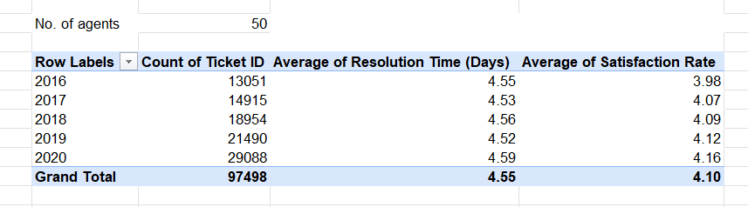

Pivot Table 2 & 3:
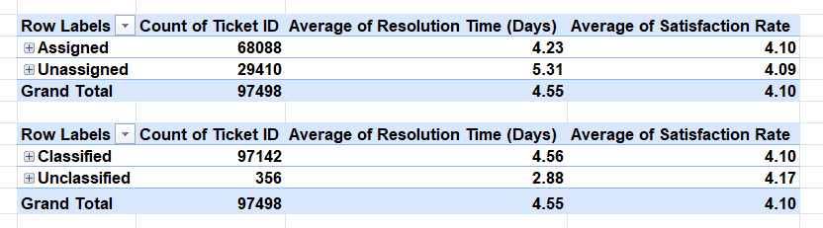
Charts:
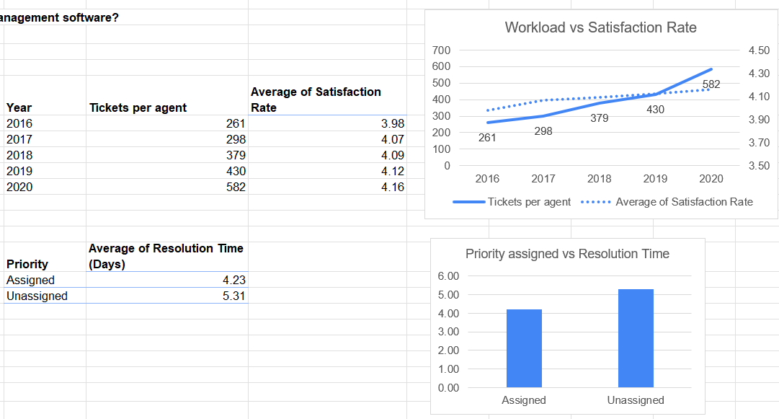

- Description:
PivotTable1 shows count of tickets, avg resolution time and avg satisfaction rate. Besides that, tickets per agent is calculated and no of unique agents is calculated to check the workload of agents.
Pivot Table 2 shows tickets priority grouped as assigned- unassigned with count of tickets, avg resolution time and avg satisfaction rate.
Pivot Table 3 shows tickets severity grouped as classified- unclassified with count of tickets, avg resolution time and avg satisfaction rate.

Insights:
- Hire more IT agent: PivotTable1 shows that although the workload keeps increasing the resolution time and satisfaction rate remains consistent suggesting no need for hiring.
- Improve training programs: PivotTable 2 & 3 shows 29410 tickets with no priority assigned having a high-resolution time. Some unclassified severity tickets are also seen which targets to need for training to identify ticket’s priority and severity levels.
- Upgrade ticket management software- PivotTable1 shows that the resolution time remains consistent over time suggesting no need for software upgrade.

Recommendations:
Training should get the investment. The only confirmed gap is of priority classification. Three out of every ten tickets were never given a priority level, which means agents are skipping an important step. Spending money on hiring or software upgrade would not fix it, but rather training agents will.

Question 2: Which agents need additional training based on their performance metrics?

Analysis: Identify agents with the lowest satisfaction ratings and longest resolution times.

Solution:

Approach:
Created columns in the table using formulas and calculated avg resolution time and avg satisfaction rate separately based on which a performance col is created which helps identify agents with low satisfaction rate than avg and having long resolution time than avg.

Charts & Tables:
- Table / Chart Name: Q-2 I Subjective
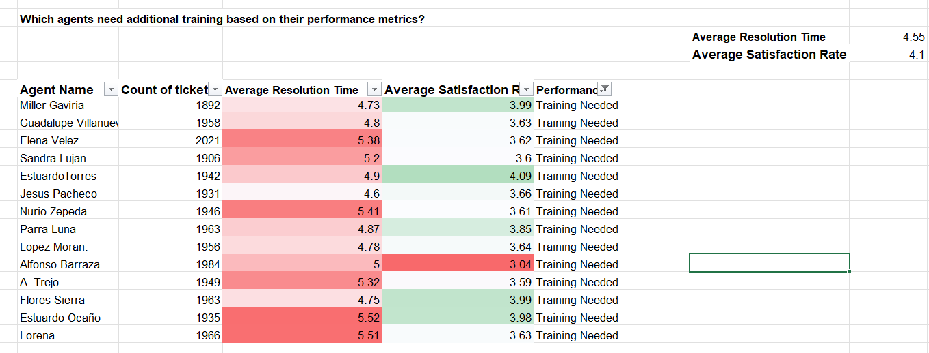
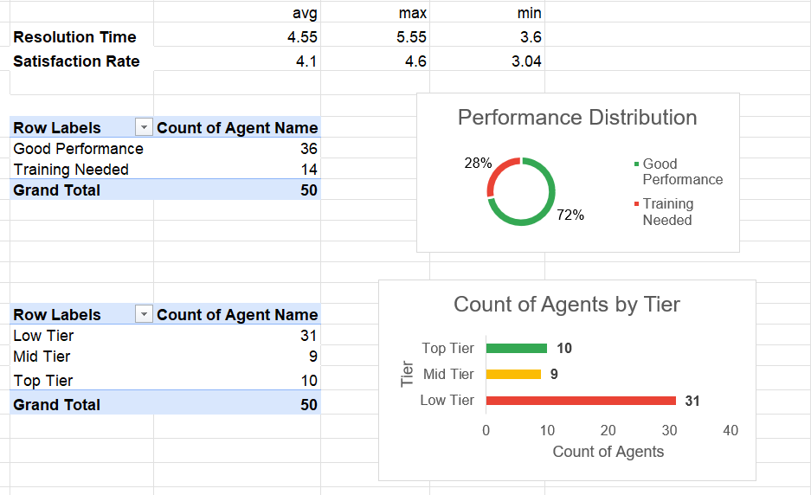
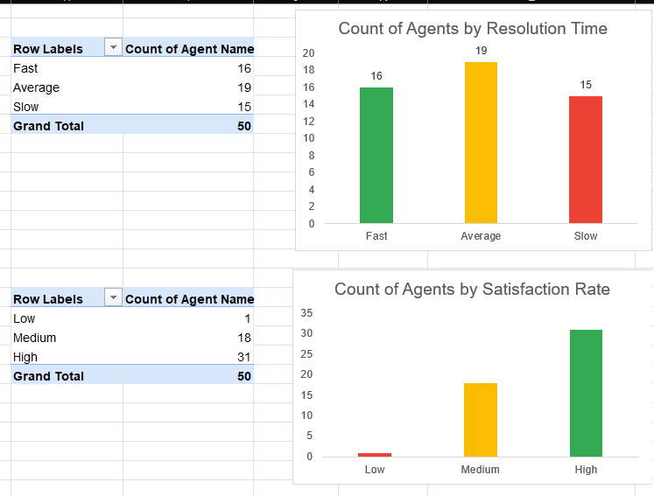
- Description:
The table is created using EXCEL formulas and conditional formatting is used to highlight agents with lower satisfaction scores and higher resolution times for easier identification. Also, avg, min and max are calculated which helped in calculation of multiple pivot tables and charts, to help decide the range for group to create tier for tier wise classification, creating buckets for resolution time distribution and satisfaction rate distribution. Further added charts for these tables, colour coding them as green, yellow, red making charts easy to read.

Insights:
Out of 50 agents, 36 (72%) are flagged as Good Performance and 14 (28%) are flagged as Training Needed based on average of resolution time and satisfaction rate. While 72% are good, the tier breakdown shows that 31 out of 50 agents fall into Low Tier i.e. a large portion of good agents are just above the threshold. Only 10 agents come into Top Tier and just 9 in Mid-Tier, showing the team is skewed with a small high-performing group and a large underperforming majority.
In resolution time distribution, 15 agents are Slow resolvers exceeding 4.9 days, which is the primary performance concern across the team. On satisfaction, 31 agents score High and only 1 agent is in Low showing satisfaction is not the issue, but resolution speed is the problem. Among Training Needed agents, Alfonso Barraza with a satisfaction score of just 3.04 showed relatively lower performance and needs immediate attention.

Recommendations:
These 14 agents can go through training among all agents. Agents who are Slow but score Medium or High on satisfaction should focus on ticket resolution efficiency training. Agents who are Fast but score Low or Medium on satisfaction should focus on communication and service quality training. Agents who are Slow and score Low on satisfaction need a combined training program for both speed and quality, and these should be treated as the highest priority cases.

Question 3: Do certain categories of requests have longer resolution times?

Analysis: Analyze the resolution times by request category.

Solution:

Approach:
I created a pivot table with Request Category in rows and Resolution Time (Days) in values. This helps understand which categories require more resolution time.

Charts & Tables:
- Table / Chart Name: Q-3 I Subjective
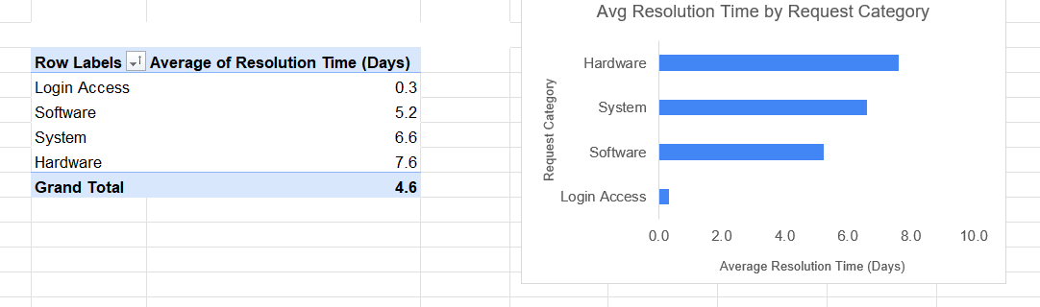

- Description:
The pivot table and chart display the average number of days required to resolve tickets across different request categories.

Insights:
Hardware Category take most resolution days while Login Access Category took the least.

Recommendations:
Hardware Category takes more than avg resolution days to resolve because it involves physical parts which needs to be repaired in person hence stocking us commonly needed parts could reduce resolution time.
Most System and Software may get stuck in the approval process or escalation. So, a proper approval process needs to be established.

Question 4: How effective are the current software tools in managing IT tickets?

Analysis: Evaluate performance metrics before and after the implementation of new tools.

Solution:

Approach:
Since the before and after implementation of new tools is not explicitly provided in the data, I have calculated a pivot chart with year as rows and count of tickets, avg satisfaction rate and avg resolution time to check if the software could handle the increasing no of tickets over the years and whether the two metrics deviate in performance. Also added priority and severity as a filter to check how software tools handle high severity and high priority tickets.

Charts & Tables:
- Table / Chart Name: Q-4 I Subjective
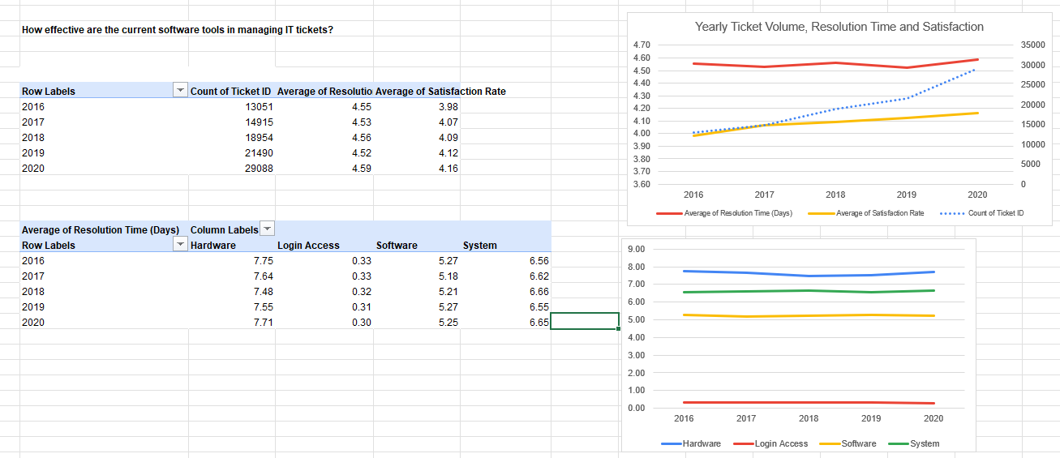
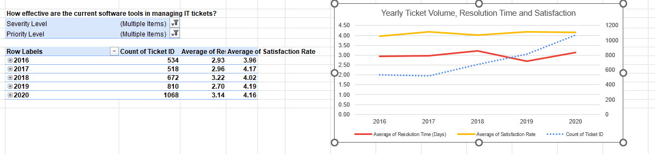
- Description:
The table and chart show the yearly changes in ticket volume, average resolution time, and satisfaction rate showing the effectiveness of the current ticket software. The changes over the years can also be seen category wise. Also added filters for severity and priority.
Insights:
Ticket volume increased a lot from 2016 to 2020, and Satisfaction rate improved from 3.98 to 4.16 in this duration while resolution time stayed nearly the same.
After applying filter to only high priority and high severity ticket, it’s clear that the resolution time has increased over the years.
Recommendations:
The current software tools appear quite effective performing very well even after 5 years and do not show signs of performance issues hence no change or upgrade needed. However, if high priority and high severity tickets increase in number then software tools upgrade might be considered for manage increasing resolution time.

Question 5: How has the performance of the IT support team changed over time (e.g., monthly or quarterly)?

Analysis: Trend analysis using time series charts.

Solution:

Approach:
I created two pivot tables to show IT support team's performance over time, used Quarter and year in the first and only quarterly in the second as the time dimension. Performance was measured using Average Resolution Time (Days), Average Satisfaction Rate, and Ticket Volume as they represent efficiency, user experience, and workload. Then I created line chart to show the trend analysis on quarterly basis.

Charts & Tables:
- Table / Chart Name: Q-5 I Subjective
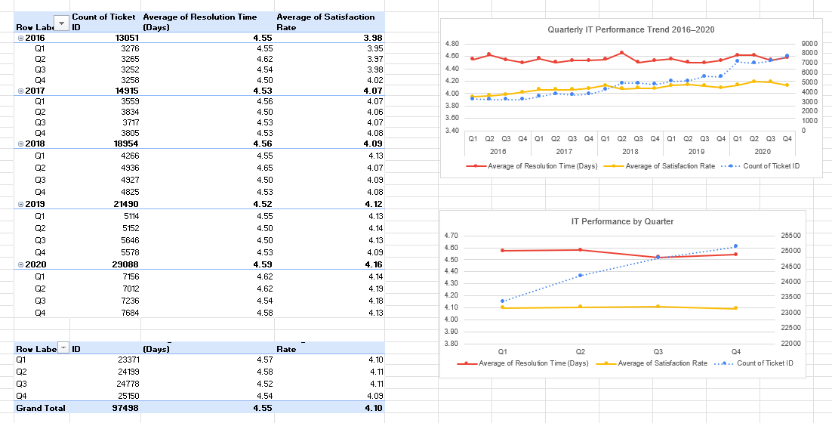- Description:
The Pivot Table and chart display quarterly changes in ticket volume, average resolution time, and average satisfaction rate to evaluate how IT support performance changed over time.

Insights:
Although there’s not major variation from 2016 to 2020. Overall the IT support performance increased over time as even with increasing no of tickets the average resolution time stayed consistent and average satisfaction rate kept increasing from Q1 to Q4. To maintain such consistency over years and quarters with increasing tickets performance should be consistent.

Recommendations:
Since ticket volume continues to increase, resource planning and training may help maintain current performance levels.

Question 6: If we invest more on tech (Hardware, software, etc), do you think it will improve the ticket resolution times and employee satisfaction?

Analysis: Use historical data to project potential improvements.

Solution:

Approach:
As we looked in the 3rd question, Hardware, System and Software had high resolution days and may benefit from some investment so for that I checked the yoy change in both the resolution time and satisfaction rate first by creating a pivot table and then created two other pivot tables to check the category wise change over the years for both. Linear Trendline was used to project resolution time and satisfaction rate beyond 2020, forecasting performance for 2021 and 2022 based on the historical trend between 2016 and 2020.

Charts & Tables:
- Table / Chart Name: Q-6 I Subjective
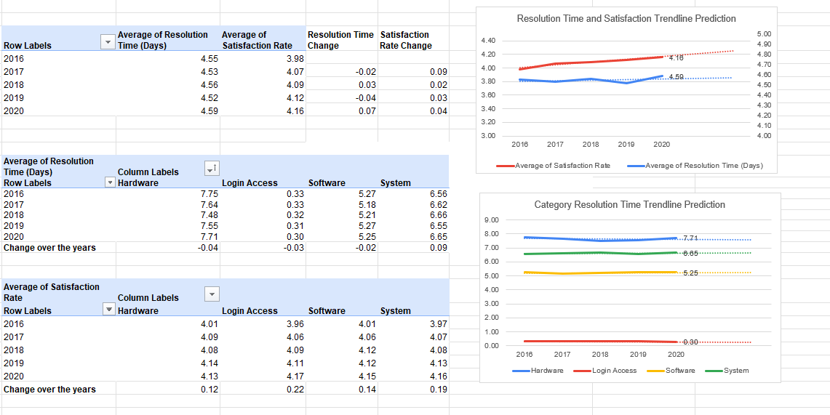- Description:
The pivot table and chart display changes in average resolution time and average satisfaction rate across categories over multiple years and the line charts show the same with trendline prediction extending to 2021 and 2022, showing satisfaction will continue rising while resolution time across all categories remains flat.

Insights:
The line charts shows that both the satisfaction rate and resolution time remains consistent with satisfaction rate jumping from 3.98 to 4.16 from 2016 to 2020. Category wise analysis remains the same.
- Hardware having the highest resolution time showing very low decrease of 0.03 over the years.
- System shows the same pattern standing 2nd highest in resolution time and shows increase in resolution time by 0.09 over the years.
- Software remains 3rd highest in resolution time showing 0.02 decrease over the years.
- Login Access has the least resolution time and shows progress over the years.
The Categories does not show much deviation in values over the years showing that even with increasing tickets the tech is stable and not increasing performance. Although the thing which could be improved is the high-resolution time across categories.

Recommendations:
Investment in technology may improve both satisfaction rate and resolution time if investment is applied accordingly across Hardware, Software and System category to reduce resolution time.

Question 7: What are the key performance metrics for IT agents, and how can they be improved, do we need to fire any agents?

Analysis: Define and analyze metrics such as average handling time, satisfaction scores, and number of tickets resolved.

Solution:

Approach:
For this analysis, I used the same table I created in Question 2 and reused it to evaluate overall IT agent performance. The key performance metrics for IT agents are Count of Tickets handled, Average Resolution Time, Average Satisfaction Rate, and Performance Classification. Based on these KPI, I have analysed how they are performing, what can be improved and if anybody needs to get fired.One employee whose performance was low I have checked year wise performance if it is consistent bad performance or due to bad performance in one year whole performance is affected.

Charts & Tables:
- Table / Chart Name: Q-7 I Subjective
Agent Name | Count of tickets | Average Resolution Time | Average Satisfaction Rate | Performance
Aurelio Tanori | 2027 | 4.51 | 4.41 | Good Performance
Jesus Contreras | 2026 | 5.55 | 4.34 | Good Performance
Elena Velez | 2021 | 5.38 | 3.62 | Training Needed
Melinda | 2007 | 4.37 | 4.4 | Good Performance
Barbara Grijalva | 2003 | 4.23 | 4.44 | Good Performance
Willyberto Gonzales | 2000 | 4.26 | 4.38 | Good Performance
Galindo Guadalupe | 1991 | 3.66 | 4.47 | Good Performance
Barraza Alberto | 1988 | 5.24 | 4.19 | Good Performance
Guadalupe Torrico | 1987 | 3.67 | 4.36 | Good Performance
Alfonso Barraza | 1984 | 5 | 3.04 | Training Needed
Alberto Casillas | 1974 | 4.3 | 4.42 | Good Performance
Silvia Morales | 1974 | 4.89 | 4.12 | Good Performance
Mata Lucero | 1969 | 5.45 | 4.34 | Good Performance
JesusGrajeda | 1968 | 3.6 | 4.47 | Good Performance
Isela Leyva | 1968 | 3.65 | 4.22 | Good Performance
Aldo Carrillo | 1966 | 4.55 | 3.78 | Good Performance
Lorena | 1966 | 5.51 | 3.63 | Training Needed
Flores Sierra | 1963 | 4.75 | 3.99 | Training Needed
Parra Luna | 1963 | 4.87 | 3.85 | Training Needed
Leon Lourdes | 1961 | 3.71 | 4.34 | Good Performance
Marisol Piedrahita | 1960 | 3.83 | 4.44 | Good Performance
Guadalupe Villanueva | 1958 | 4.8 | 3.63 | Training Needed
Lopez Moran. | 1956 | 4.78 | 3.64 | Training Needed
Rosa Olguin | 1950 | 5.32 | 4.32 | Good Performance
Velasquez Jose | 1949 | 4.52 | 3.69 | Good Performance
A. Trejo | 1949 | 5.32 | 3.59 | Training Needed
Ramon Macias | 1949 | 5.45 | 4.2 | Good Performance
Nurio Zepeda | 1946 | 5.41 | 3.61 | Training Needed
Darwin E. | 1945 | 4.06 | 4.36 | Good Performance
Eva Cardenas | 1943 | 4.72 | 4.41 | Good Performance
EstuardoTorres | 1942 | 4.9 | 4.09 | Training Needed
Enrique Montiel | 1938 | 4.64 | 4.44 | Good Performance
Estuardo Ocaño | 1935 | 5.52 | 3.98 | Training Needed
Yomaira Agudelo | 1933 | 3.82 | 4.17 | Good Performance
Segura Garcia | 1931 | 3.72 | 4.46 | Good Performance
Jesus Pacheco | 1931 | 4.6 | 3.66 | Training Needed
Luis Arguello | 1929 | 3.7 | 3.82 | Good Performance
Diana Rojo | 1927 | 3.64 | 4.6 | Good Performance
Orci Carlos | 1926 | 4.32 | 3.67 | Good Performance
Alfredo Barreras | 1920 | 4.29 | 3.67 | Good Performance
Eduardo Luna | 1920 | 4.41 | 4.15 | Good Performance
Guadalupe Hernandez | 1915 | 4.56 | 4.38 | Good Performance
Luis Torres | 1913 | 3.92 | 4.2 | Good Performance
Sandra Lujan | 1906 | 5.2 | 3.6 | Training Needed
Reyna Santacruz | 1897 | 3.85 | 3.91 | Good Performance
Javier D. | 1897 | 4.06 | 4.49 | Good Performance
Miller Gaviria | 1892 | 4.73 | 3.99 | Training Needed
Armando Sierra | 1890 | 5.34 | 4.36 | Good Performance
Alberto Gastelum | 1889 | 3.71 | 4.4 | Good Performance
Griselda Galindo | 1856 | 5.32 | 4.28 | Good Performance

Row Labels | Count of Ticket ID | Average of Resolution Time (Days) | Average of Satisfaction Rate
Alfonso Barraza | 1984 | 5.00 | 3.04
2016 | 290 | 4.99 | 2.84
2017 | 284 | 5.12 | 2.88
2018 | 400 | 4.96 | 3.03
2019 | 391 | 4.54 | 3.17
2020 | 619 | 5.26 | 3.14

- Description:
The table shows the names of all 50 Agents with the count of tickets resolved by them, average resolution time taken to resolve those tickets, average satisfaction rate which shows how satisfactory there resolution was and finally performance metric calculated in que 2 which is helpful I identifying which agent is performing good and which might need training.
A scatter plot clearly showing best performers in the top left corner and worst in the right bottom corner of the chart.
Also I created a pivot chart to check if alfonso barraza performance was bad in a year or consistently.

Insights:
- Agents resolving 2000+ tickets frequently have resolution times above 4.5–5.5 days which can clearly indicate to large workload but just below it we have two agents performing well Galindo Guadalupe and Guadalupe Torrico as well as one with very poor performance Alfonso Barraza.
- Diana Rojo and Javier D. are the best performer as seen in the top left corner of the chart and Alfonso Barraza is the worst and lie at the bottom right corner with more resolution time and less satisfaction.
- Creating separate table for alfonso shows the performance has been consistently low.

Recommendations:
They can be improved by diff kinds of trainings.
Like selecting top 5 people for different responsibilities for example top left corner or top performers Jesus Grajeda, Diana Rojo, Isela Leyva, Galindo Guadalupe and Guadalupe Torrico can guide other with their way and act as mentors or seniors.
Top right having high satisfaction and high resolution time can go through ticket resolution related training.
Botton left having low satisfaction and low resolution time can go through communication and user experience related training and the agents in bottom right should go through all kinds of training.
Alfonso Barraza could be fired for consistently bad performance over the years.

Question 8: How do employee demographics (e.g., department, seniority) impact satisfaction and ticket outcomes?

Analysis: Segment analysis using filters and pivot tables.

Solution:

Approach:
For employee demographics, there’s only age column which I can use by creating groups for different age bands and calculate satisfaction, resolution, and cout of tickets resolved and added severity and priority filters to check the level of difficulty and priority vs seniority. For that I check the min age=29 and max age=54 and the closest I could get the grouping in this range was by 9 hence created 29-37,38-46 and 47-55 groups naming them as LOW,MID and HIGH, assuming higher age = higher experience. Also created a clustered column chart which makes is easy to see the pattern.

Charts & Tables:
- Table / Chart Name: Q-8 I Subjective

Image1:
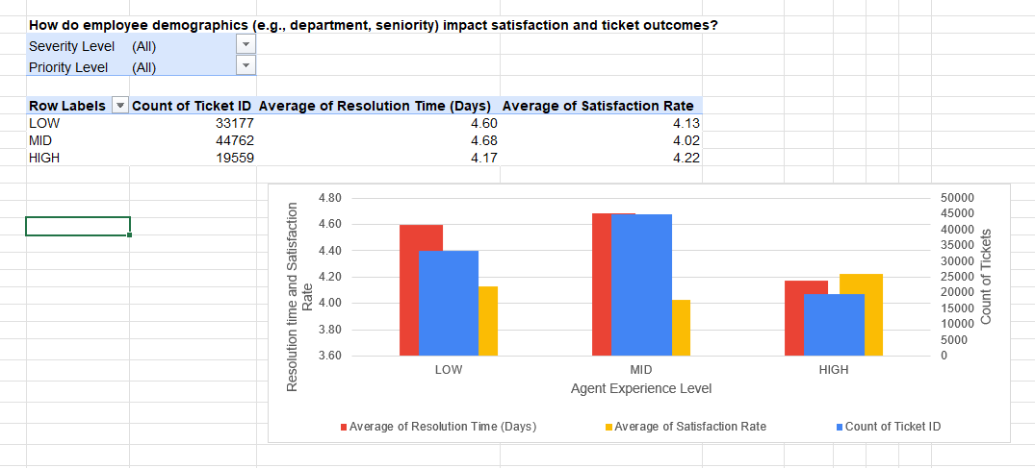
Image2:
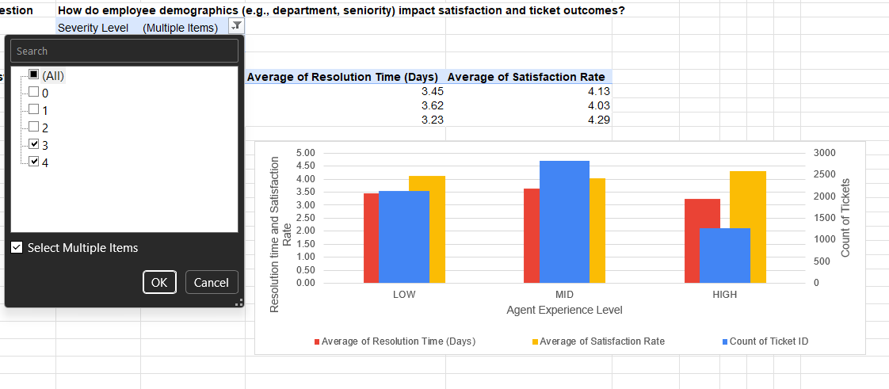
Image3: 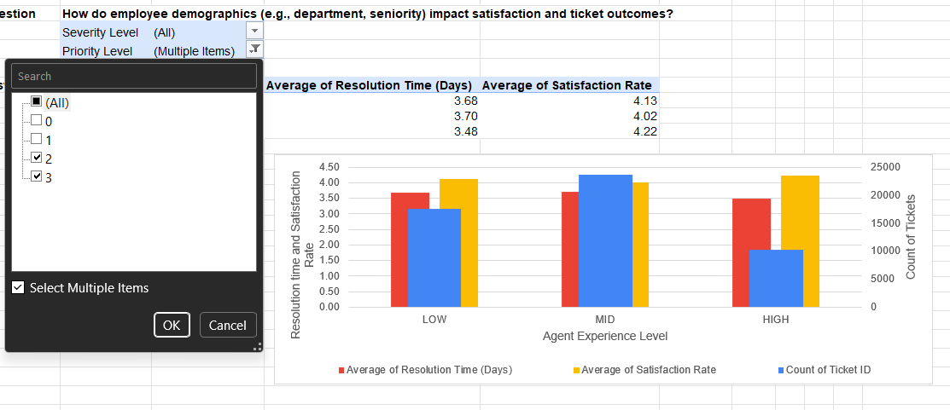
Image4:
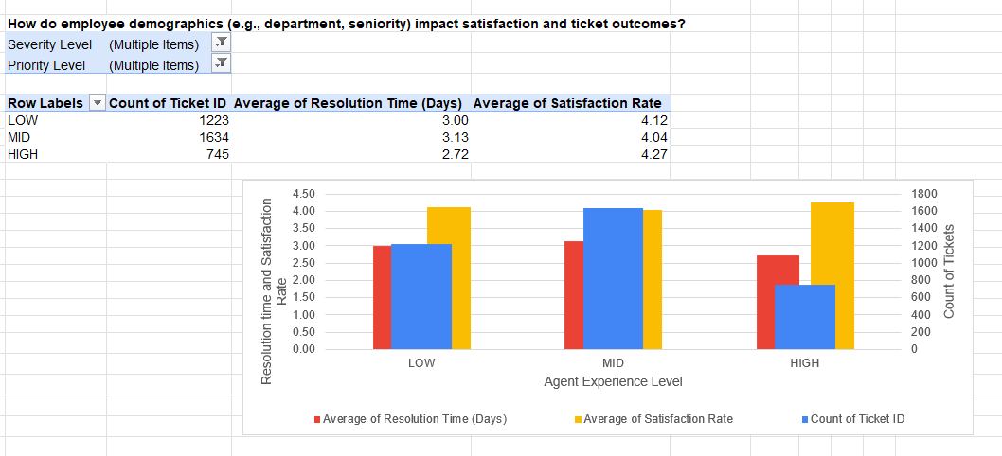
- Description:
The images show a pivot table and chart with severity and priority as filters. One table showing all tickets, one filtered to Severity 3 and 4, one filtered to Priority 2 and 3, and one filtered to both Severity 3 and 4 and Priority 2 and 3 combined. A clustered column chart shows Avg Resolution Time, Avg Satisfaction Rate, and Count of Tickets side by side by Age Group.
Insights:
Image 1: The MID age group solves the most tickets but has the highest resolution time and the lowest satisfaction rate. The HIGH group solves the fewest tickets even though it has the lowest resolution time and the highest satisfaction rate. The LOW group sits in between.
Image 2: After filtering Severity 3 and 4 only, the same pattern is there, MID leads in ticket volume and resolution time remains highest, while HIGH maintains the best satisfaction rate and lowest resolution time.
Image 3: After filtering Priority 2 and 3 only, the ticket distribution and satisfaction rate pattern remains the same. However, resolution time lowers slightly across all groups, HIGH again shows the lowest resolution time and highest satisfaction, confirming this group gets faster and better regardless of priority level.
Image 4: When both Severity 3 and 4 and Priority 2 and 3 are applied together, resolution times drop significantly for all groups. HIGH still resolves fastest and scores the highest satisfaction while MID again has the most tickets and lowest satisfaction, confirming the pattern is same across.

Recommendations:
The MID age group consistently shows the highest ticket volume, longest resolution time, and lowest satisfaction, this segment needs targeted attention and training.
The resolution and satisfaction as seen in the HIGH group is consistently better across all severity and priority combinations. The handling approach for this group should be studied and followed by other age groups.

Question 9: Identify the trends for IT support operations based on ticket volumes and satisfaction, and mention the peak and stable times?

Analysis: Use pivot tables and charts to identify peak and off-peak hours.

Solution:

Approach:
In the data, the date column does not have time related information hence I went with monthly analysis.

Charts & Tables:
- Table / Chart Name: Q-9 I Subjective
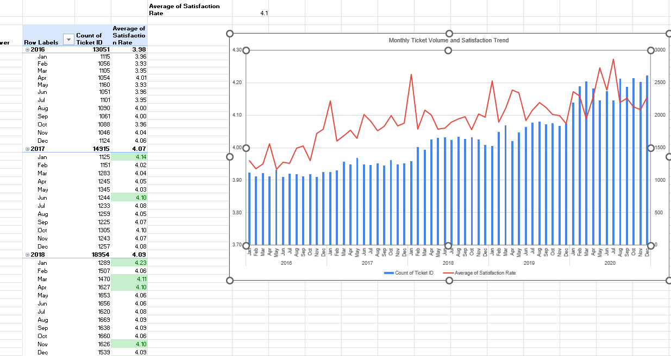

- Description:
The table shows the year-month count of tickets across all five years and all 12 months with average satisfaction rate and a combo bar and line chart makes it more suitable to track peak and stable times.

Insights:
2020 consistently shows the highest monthly ticket volumes across almost every month compared to prior years. I noticed the time from Feb to Mar and August to Dec have high volume of tickets and Jan and July having the least no of tickets showing maybe some end of year and end of financial year deadline for ticket resolutions. Jan is the most stable ticket volume wise and have the highest satisfaction rate just not in 2020.
The chart shows an inverse relation between count of tickets and satisfaction rate as there’s a sudden dip in Feb and March in satisfaction rate and increase of no of tickets.
July shows good satisfaction rate despite high no of tickets showing midyear adaptability.
Ticket volumes show consistent YoY growth, rising from around 13K in 2016 to around 29K in 2020, more than doubling over five years, also the conditional formatting for satisfaction rate clearly shows more values lying above average satisfaction rate values year over year.
Recommendations:
Since volumes are growing every year, staffing and training should be scaled up proportionally, not just seasonally.

Question 10: What metrics should be included in the final dashboard to provide a comprehensive view of call center performance and guide investment decisions?

Solution:

Approach:
To provide a proper understanding of overall call center performance and support better investment decisions, the dashboard should include important operational, customer satisfaction, and employee performance metrics. The dashboard should help identify areas where the company is performing well and where improvements or investments are needed.
The dashboard should mainly include metrics such as:
- Total Ticket Volume
- Average Resolution Time
- Average Satisfaction Rate
- Ticket Count by Request Category
- Ticket Count by Severity and Priority
- Quarterly or Yearly Ticket Trends
- Agent Performance Metrics
- Resolution Time Distribution
- Satisfaction Score Distribution

Interactive slicers such as Year, Severity, Priority, Issue Type, and Request Category should also be included so that users can filter the dashboard dynamically and perform detailed analysis easily.

Charts & Tables:

Insights:
- Ticket volume increased continuously from 2016 to 2020, showing increasing workload over the years.
- Resolution time remained relatively stable despite increasing ticket volume, indicating consistent operational performance.
- Hardware, Software, and System categories showed comparatively higher resolution times and may require more operational attention.
- HIGH experience agents maintained lower resolution times and better satisfaction rates even while handling workloads like MID experience agents.
- Severity and Priority levels had great impact on ticket resolution performance and satisfaction.
- Satisfaction scores remained mostly stable over the years, indicating that service quality was maintained despite growing ticket counts.

Recommendations:
- Regularly monitor category-wise resolution time to identify areas requiring technology or process improvements.
- Agent performance tracking should be included for identifying training needs, workload balancing, and performance optimization.
- Severity and Priority monitoring should be used for better resource and ticket allocation decisions.
- Interactive slicers should be there on dashboards to improve usability and allow faster business decision-making.
- With quarterly and yearly, if timestamp is used to store Date, then time related (hourly rate) monitoring can also be done to support future hiring, budgeting, and investment planning.

